"Introduction to APIs: Enabling Modern Application Integration"

Connection without API

Every business need web application, Android App and iOS app to implement business logic .if these **Front-end frameworks communicate directly with the Database**  some problems may occur.

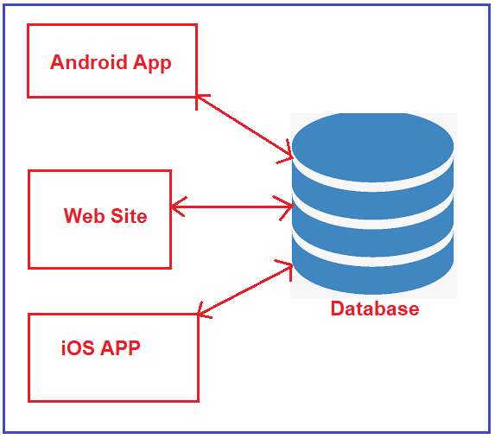

Some problems

* **Duplicate logic for each Application**
* **Error-Prone Code**
* **Some Front-end frameworks cannot communicate directly with the Database**
* **Hard to Maintain**

Use of API

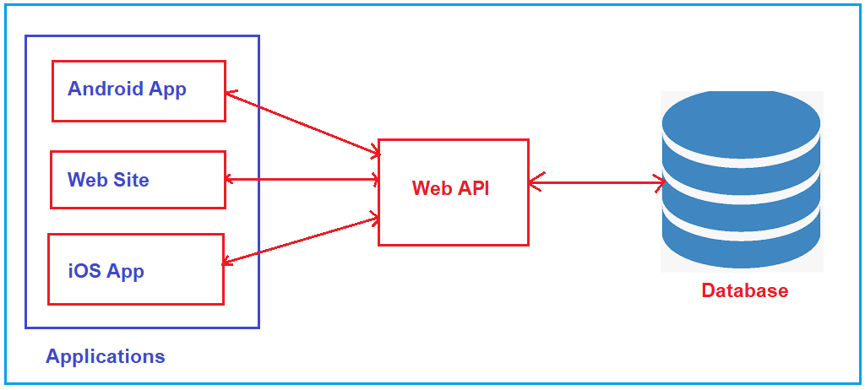

Web API acts as a mediator between the Front-End and Back-End. The entire business logic will be written in the Web API project only.

Key Characteristics of Web APIs:

* **HTTP-Based Communication**
* **Data Exchange Formats**
* **Authentication and Authorization**
* **RESTful Principles**

**RESTful Principles**

* **Independent Client-Server Architecture**
* Stateless Communication
* Unique URL
* Content Negotiation
* Layered System

Frameworks for Creating APIs

|  |  |  |
| --- | --- | --- |
| Framework | Language | Description |
| ASP.NET Core | C# | A cross-platform framework for building modern, cloud-based web applications and APIs. It supports RESTful services and is highly performant. |
| Express.js | JavaScript (Node.js) | A minimal and flexible Node.js web application framework that provides a robust set of features for web and mobile applications. Ideal for building RESTful APIs. |
| Django REST Framework | Python | A powerful and flexible toolkit for building Web APIs in Django. It provides features like authentication, serialization, and view sets. |
| Flask | Python | A lightweight WSGI web application framework that is easy to use for building APIs. Flask-RESTful is an extension for building REST APIs quickly. |
| Ruby on Rails | Ruby | A full-stack web application framework that includes built-in support for creating RESTful APIs. It follows the convention over configuration principle. |
| Spring Boot | Java | A framework that simplifies the development of Java applications, including RESTful APIs. It provides built-in support for creating stand-alone applications. |

Why We Need ASP.NET Core Web API?

* The **ASP.NET Core Web API** is an excellent framework for building HTTP services that can be consumed by a broad range of clients, including browsers, mobiles, iPhones, and tablets. ASP.NET Core Web API provides several benefits:
* **Performance**
* **Cross-platform**
* **Modularity**
* **Modern Features**
* **Security**

**HTTP Protocol Methods**

* a client can consume these resources (perform CRUD Operations) by using **HTTP Protocol Methods** (**GET, POST, PUT, DELETE**) and URIs. For example, a RESTful API for a book management system might include endpoints like:
* **GET /books –** Retrieves a list of books.
* **GET /books/{id} –** Retrieves details of a specific book.
* **POST /books –** Adds a new book.
* **PUT /books/{id} –** Updates details of a specific book.
* **DELETE /books/{id} –** Deletes a specific book.

Thanking you…